**NAME: ABDURRAHMAN QURESHI**

**ROLL NO: 210451**

**EXP1.1**

**Create a web page to display the name of your college and save it with your name.**

__________________________________________________________________________________

**Code:**

<html>

<html>

<head>

<title>EXP1.1</title>

</head>

<body>

<h1>M.H. Saboo Siddik Polytechnic</h1>

</body>

</html>

**Output:**

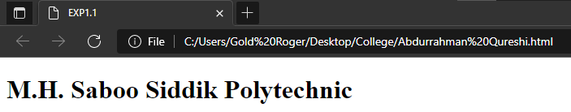

**EXP1.2**

**Create a web page to display name of any IT company you know and save it with your Roll No.**

__________________________________________________________________________________

**Code:**

<html>

<html>

<head>

<title>EXP1.2</title>

</head>

<body>

<h1>Microsoft</h1>

</body>

</html>

**Output:**

